Extract of a letter to the Environment Protection Authority in Darwin, June 27, 2018.
Re Alleged illegal landfill dump behind Minmarama Village
While visiting the [Minmarama] community in 2009 I heard several complaints that the dump used for domestic rubbish by the villagers (itself of doubtful legality) had been fenced off with a locked gate for the exclusive use of a construction company. It appeared that the dumping was the result of a secret deal between the leaseholders and Venturin, which was the name I was given for the construction company involved.
The leaseholders are the Gwalwa Daraniki Association Inc ... I note that the [Minmarama] community is built on an old landfill dump where a large proportion of old Darwin was dumped after Cyclone Tracy. A health worker at the Bagot Community once expressed concern to me about the health effects of building on the Council dump, citing several cases, but saying the residents were afraid to complain because of their fear of the landlord.
The reason for this follow up letter is that a few months ago I received a telephone call from the EPA in Darwin to reassure me that my original query about the dumping behind Minmarama was being 'looked into' and that I should be patient. I have heard nothing since then and I have never received any written reply to my questions. You will remember that my letter was accompanied by photographic evidence taken of the dump and machinery at the dump, after it was levelled and top-dressed in 2009.
I believe the leaseholders or the company need to explain what was dumped into the mangroves, whether a permit was obtained and what financial arrangements were made. I repeat, I was told that the company who used the dump was the Venturin construction company.
Can the EPA please inform me of the results of their investigation if indeed an investigation was held, and if not, why not? For a start, I suggest the EPA examine aerial photographs between 1980 when the lease was granted and aerial photographs over the following ten-year periods to view the extent of the dumping. I enclose the five photos taken by myself at the dump following complaints by the Minmarama residents during my visit in 2009.
Dr Bill Day

Reply to Dr Bill Day from Peter Vasels, Director, Environmental Operations, providing services for the Northern Territory Environment Protection Authority, NT Department of Environment and Natural Resources, 10 July 2018.
Dear Dr Day
Thank you for your letter dated 27 June 2018 raising a range of concerns regarding the Minmarama Village located at 213 Dick Ward Dr[ive], Ludmilla (also known as Lot 5182, Town of Darwin). Your concerns include dumping, the stockpiling of material, and concern for contamination at Minmarama Village.
As you're aware, officers for the Northern Territory Environment Protection Authority (NT EPA) investigate reports of unauthorised dumping (including the unapproved use of waste concrete and construction rubble as fill) that are reported by members of the public. Where unauthorised dumping/landfilling is able to be directly linked to a responsible party, the NT EPA is able to take action under the Waste Management and Pollution Control Act (WMPC Act).
Since your initial letter and photographs were provided, officers have been in discussions with other government departments with historical knowledge of the area and researched available information (including reviewing aerial images).
To address one of your primary concerns that Minmarama Village is located on an historical 'Council' landfill site, officers have been unable to find evidence in any imagery to confirm this [my emphasis]. However, what is already known is that a landfill used for disposal of Cyclone Tracy wastes was located to the north of the Minmarama Village in the area now covered by the stockpiles of fill material. No houses have been built on this area.
In relation to the stockpiled fill material itself, officers were involved in initial discussions between the Department of Infrastructure, Planning and Logistics, Halikos Group, representatives of Gwalwa Daraniki Association Inc and others to identify uses for this stockpiled fill material. It is understood that these discussions remain ongoing, but preliminary 3rd party testing of the stockpiles for asbestos contamination indicated that the stockpiles material posed no significant risk [my emphasis].
The images you provided regarding the alleged dumping/filling behind Minmarama Village by 'Venturin' in 2009, have also been reviewed in light of other available information. Officers have determined that an area of land behind Minmarama Village itself was disturbed and infilled and that concrete wastes and rubble was used at least in part for fill. No evidence of anything other than concrete/construction rubble wastes has been identified and the NT EPA has not received any reports or is aware of significant contamination in or from the filled area.
The filling of land for reclamation requires a development permit issued under the Planning Act. Officers are unable to locate any permits or approvals granted by any government agency for reclamation behind Minmarama Village. Officers have also been unable to determine what, if any, financial or other non-regulatory arrangements may have been in place that allowed the filling, or been able to satisfactorily determine who may have conducted these activities in 2009 [my emphasis].
More recently however, officers have investigated and taken action against a company observed dumping fill in the area.
If any further development of 213 Dick Ward Dr, Ludmilla is proposed in the future, the NT EPA will recommend assessment of the underlying fill and also classification of all new fill that may be used, to ensure it is suitable for use at this location.
Again, thank you for your information in this matter and please contact me should you require further information.
Yours sincerely
Peter Vasel
Director, Environmental Operations.
Author's Note: In response to the above, the following pages are a review of media and other sources documenting the history of the waste dump in Ludmilla from December 1971 and the eventual construction of Aboriginal housing on the old dump site in 1989.
Residents Move to Block Ludmilla Dump Plans, NT News December 31, 1971, page 26.
Residents of Harney Street at Ludmilla North will be asked to form a committee to get the City Council to abandon its plan to establish a wet garbage dump “at their back doors.” … Six people who were interviewed all live at the Fitzer Drive end of Harney Street with their back fences or front balconies only a stone's throw from the proposed dump. They are so close they can see the heaps of overburden piled ready to cover the garbage as it is dumped … Mr Goldenstein said he was amazed that the City Council had excavated good, level land to start the dump. “They could have gone 300 yards further in where the land slopes down into the mangroves,” he said.
Mr Jim Urquhart from across the road, left no doubt how he felt about it. “If they are going to put in sports grounds for the kids OK, if they're not I'm completely against it.”
[Mr Urquhart] said there was a desperate need for sport arenas in the area because there was nowhere for the children to play games … He said there were a lot of children in Harney Street and there were no sports grounds nearer than Nightcliff or the city.

Aldermen Stand Firm On Ludmilla Dump, NT News January 1, 1972, pages 1&6.
Alderman Peter Spillett said he felt he felt very strongly about the matter. “We will be reclaiming land for parklands and sports arenas. The whole scheme had the blessing of NT Administration and the Department of Health. By reclaiming this land we would not only be providing valuable facilities but getting rid of mosquito and sandfly breeding grounds. I won't say there will be no nuisance. There will be some for a while. But when you think of the benefits that could accrue after 12 months it will be worthwhile.”
The Mayor, Alderman Ken Waters said... “As may be seen by the plan this can only enhance the value of homes in that area within a few short years.”

Mayor Calls For Public Support On Dump, NT News January 14, 1972, page 6.
Alderman Waters said that a Local Government Association representative who had studied garbage disposal in America, Asia and Europe had found that controlled tipping “if efficiently carried out, represents the most economical and satisfactory solution to the garbage disposal problem.” This method has changed the present golf course area, Mindil Beach foreshore, a large area of the Botanical Gardens and other areas from mosquito ridden swamps to “the pleasant areas which are familiar to all,” Alderman Waters said.

Who Owns Dump Land? NT News January 15, 1972, page 1.
The Darwin City Council should insist on title to land reclaimed by the garbage dumps the Member for Ludmilla, Mr Dick Ward said last night. Mr Ward was firing the latest shot in the Ludmilla dump controversy. He said as far as he could see the Council had no rights to fill the area, except a Health Department clearance, but this gave no title. It could amount, in the end, to the people of Darwin paying to create valuable land which could then be subdivided and sold back to them at premium prices by the Government. Mr Ward said he was aware of the fact that announcements had been that the area would be available for sports ovals or parkland. But there was no guarantee of this unless the title to the land was vested in the City Council.[Note: Dick Ward became the Interim Land Rights Commissioner in 1975].

Council Plans Rigid Control Over Dumps, NT News January 19, 1972, page 2. Tough measures to enforce stringent health and pollution controls over rubbish dumps will be adopted on Monday by Darwin City Council ... They will also apply at the proposed Ludmilla tip, now planned to open immediately after the start of the dry season. Ludmilla residents have organised a strong campaign against the tip plan because they fear smells, health and traffic hazards.

'Trouble' Threat if Ludmilla Dump Opens, NT News January 20, 1972.
The City Council will find itself in “a hell of a lot of trouble” if it goes ahead with plans to establish a wet dump at Ludmilla, Mr Michael de Nieuwe said yesterday. “We will oppose the opening of the dump in every way possible,” Mr de Nieuwe said. “If necessary we will sit down in front of council trucks to prevent them getting into the dump area,” he said ... “If the rubbish is to be covered immediately so that flies won't be attracted and there will be no smell, this will mean a bulldozer working at night, which we don't want.”

Editorial: Look Before The Leap..., NT News January 20, 1972, page 2.
As for the dump reducing the land values of places in Ludmilla … if this was so at all … it would obviously be only temporary.
In the long term, and not so long at that, the reclamation of the swamp for sports ovals or parks would raise the land values...

More Protests On rubbish Tip Plan, NT News January 24, 1972, page 3.
Ludmilla residents will take out an injunction against the Darwin City Council if it goes ahead with plans for the Ludmilla dump at its meeting tonight...

City Council Take Over Dump Control, NT News January 25, 1972, page 1.
At a two-minute meeting last night, the Darwin City Council took control of the Snell Street garbage dump from the contractors, M. J. Hannon Pty Ltd ... A protest group organised by a Ludmilla resident Mr Michael de Nieuwe was thwarted by the early start of the meeting ... “This is just building up our case in the event of us asking a court for an injunction to stop the opening of the [Ludmilla] dump,” he said. Another member of the protest group, Mr Brian Manning, secretary of the Territory's Trades and Labour Council, said if the council wanted to play tricks on the people who had an honest interest in the opening of the dump at Ludmilla, then the TLC could show the aldermen a few tricks they had never heard of.

[Alderman Ken] Slide Defers Move Against The Dump, NT News January 25, 1972, page 5.
...the MLC for Fannie Bay, Mr Joe Fisher has asked that the whole question of the proposed dump be looked into very carefully before any hasty decision is made to abandon it ... He said the dump was being planned with a three-fold objective -
- to dispose of garbage
- to reclaim an obnoxious area and eliminate a mosquito and sandfly nuisance, and
- to vest in the council all the reclaimed land which could provide valuable space for recreational activities.
“Garbage dumps have a short interim life and properly controlled the nuisance factor should be small. When completed they change the nature of the environment of the particular area,” [Mr Fisher said].

Replacing Mossies With Blowflies -de Nieuwe, NT News January 27, 1972, page 11.
Mr Michael de Nieuwe, a leader in the protest against the council's proposed wet dump at Ludmilla said this yesterday. He said he had nothing against the area being filled, but not with wet garbage.

No Guarantee On Use Of Ludmilla Dump Land, NT News January 27, 1972, page 11.
When the Ludmilla swamp area is reclaimed there is no guarantee that the land will be vested in the City Council or that it will be used for sports grounds and playing fields. This was said yesterday by the Mayor, Alderman Ken Waters...
It has been taken for granted that if the Ludmilla mangrove swamps are reclaimed they will automatically be transformed into a “green belt” of parks, gardens and sports fields … Yesterday the mayor met Commonwealth and Administration officials to discuss the long range reclamation program.
“All the Government says is that the area may be reclaimed. However we do believe that to the best of our knowledge we will get it for parks and gardens.”

Dump Decision Without The People – Ward, NT News January 27, 1972, page 11.
The MLC for Ludmilla, Mr Dick Ward said yesterday he was astonished that a meeting should be held to discuss the City Council's proposed wet garbage dump at Ludmilla without the presence of a representative of the local residents... He said it was also astonishing that Alderman Waters had announced that what he euphemistically called a “modus operandi” for the dump would be for the next 30 years.
“Surely consideration should be given to whether this will not involve a generation and a half in stench, filth, flies and land and water pollution which will continue far beyond the lifetime of the aldermen who are now making the decision,” Mr Ward said.

Ludmilla Dump Takes Wet Garbage On Sunday, NT News September 27, 1972, page 4.
The controversial Ludmilla dump will receive its first load of wet garbage just after midnight this Sunday.“All the garbage will be covered immediately, and the first dumping face will be 200 yards away from the nearest house,” [The Mayor, Alderman Harold Brennan] said.
The leader of the anti-dumping forces at Ludmilla, Mr De Nieuwe said sea water getting into the dumping area would be a major problem as the dumping face moved away from the houses.

Ludmilla Dump Threat To Harbor Says Walsh [sic], NT News September 28, 1972.
Dumping Darwin's garbage at Ludmilla from next Sunday will mean “worse habor [sic] pollution that any of the proposed sewerage schemes,” Mr Bill Walsh said yesterday ... “Such a landfill dump at the edge of the sea, or in a mangrove area, will be a source of harbor pollution worse than even the original raw sewerage scheme which was rejected,” he said. “There is now world-wide recognition of the fact that landfill garbage disposal is a serious contributor to global pollution, unless strict precautions are taken. These involve ensuring the area is completely and permanently sealed off from the danger of waste leaking into waters, or of waters soaking into the dump area ... There should also be provisions to ensure the dump area is never used for any other purposes. I agree with Conservation Society president Mr Don Beaton, who said this week no mangrove areas should be 'reclaimed' until full research has been done into their ecology...The Territory Port Authority should also realise the dangers, and use its existing powers to stop the coming pollution,” Mr Wlash said.

Denial On Harbor Pollution, NT News September 29, 1972, page 7.
Port Superintendent, Mr Les Buenfeld, said the inspection had shown the harbor would not be polluted by the dump … “The dump is well away from the harbor,” Mr Buenfeld said. “There is no likelihood of it getting into the Ludmilla Creek, and if it did the mangroves would stop it. Besides, there is a long way for the dumping area to go before it even approaches the harbor … The Mayor, Ald Harold Brennan, also defended the Council's action... “We won't be going near the water for a long time... There are no fears. And if there were the Port Authority would look after it and make sure something was done.”

Walsh Challenges On Dump Pollution Danger, NT News July 30, 1972, page 7.
A conservationist warned yesterday he would seek an inquiry if the NT Port Authority did not restrain the Darwin City Council from opening the Ludmilla dump ... The authority's executive member, Mr Les Buenfield, said [this week], the harbor would not be polluted as any pollutants would be stopped by the mangroves if they got into the Ludmilla Creek ... Mr Walsh said it was absurd to suggest the mangroves would miraculously stop any pollution ... He accused the authority of failing to do its duty in enforcing its two anti-pollution laws...

New Dump's Smells, Noises, NT News October 5, 1972, page 7.
Residents near the new Ludmilla dump which opened this week have already suffered from noisy trucks and foul smells … Long time dump opponent Mr Michael De Nieuwe said there had been “quite a racket” caused by the trucks bringing garbage to the dump of a night.

Dump: Nose Reason To Complain – Brennan, NT News January 4, 1974, page 11.
Photo caption: “Two men unload rubbish at the Ludmilla dump yesterday. Residents have complained of the offensive smell coming from the dump, especially after rain. The Mayor, however, says the dump is in 'good condition.'”

Stink (Heading on a letter to NT News), January 9, 1974, page 8.
“Before the garbage dump was established it was impressed upon the council by a group of local residents and others just what problems a garbage dump in this area would cause … their comments fell on deaf ears.” IRATE, Ludmilla North.

Stench (Heading on a letter to NT News), January 11, 1974, page 8.
“Surely something can be done. After all, the disposal of rubbish has been a problem since the year dot when the first caveman threw away the first bone. Surely our experts have learned something since then.” H Cornfield, Ludmilla.

Smell (Heading on a letter to NT News), January 23, 1974, page 8.
On Saturday I went visiting in Ludmilla and I found out exactly why people complain. The Ludmilla dump smelt worse than a pigsty. I wonder just how Ludmilla residents can enjoy their meals with such a revolting malodorous smell.” Mary Beames, Rapid Creek.

Ludmilla Plagued By Dump Flies, NT News May 3, 1974, page 10.
Photo caption states, “What the people of Ludmilla have to put up with.”
The area of the dump was extended last week and is now only a stone's throw from houses in Nemarluk Court. The residents have complained that they can no longer eat outside because of the flies and the smell … Mr Clunies Ross (City Council) said the dump would be in operation at least until October. He said the rate of filling had dropped considerably because people were taking their rubbish to the free dump at Leanyer, beyond the northern suburbs.
Eventually the [Ludmilla] dump area will become a park with playing fields.

Dump 'Not A Hazard', NT News May 4, 1974, page 3.
Millions of flies and a vile smell have plagued people who live close to the dump following its extension last week. [Alderman Brennan said] This problem was being corrected by covering the garbage with soil and the dump has been sprayed to reduce the number of flies...

Health (Heading on a letter to NT News), April 25, 1974, page 8.
“I must admit I was more than appalled to see people at the Ludmilla rubbish tip, ripping open sealed rubbish bags, searching through fermenting food-stuffs and carcasses with their bare hands – and coming away with such items as half used bottles, empty food containers etc., in full view of the tip supervisors.” M G H, Nightcliff.
Goodbye Ludmilla Smells – In About 3 Months. NT News January 28, 1974, page 3.
The Ludmilla dump was filling faster than had been anticipated, Alderman [Ellen] Stack said.
When it was filled it would be planted with grass, trees and shrubs and turned into parkland and playing fields.
Subsidence is a risk
No roads or buildings could be built on the area for 20 years because of the risk of subsidence. According to the town plan the whole of the area was designated green belt.

Noses Up At Dump Plan, NT News July 31, 1974, page 2. By Rex Clark
Ludmilla residents and conservationists are raising a last-minute “stink” over planned extensions to Darwin's garbage dump. The City Council will tonight decide whether to proceed with the plan. The Department of the NT has approved the use of 21 hectares (50 acres) to extend the dump. The land extends from Fitzer Drive almost to Bagot Road and west to mangrove swamps. The residents, who don't like the dump close to their homes anyway, complain that natural bush has already been bulldozed … Mr Rowan, a civil engineer, suggested that extensive layers of rock just below the surface could upset the council's cost estimates … [see Map 1].
The extension is also being opposed by the Gwalwa Daraniki land rights association. The secretary, Mr Bill Day, says the land already cleared is not the area approved by the association early this year [by] the Aboriginals for use as a dump. He said Mr Justice Woodward's land rights report recommended the vacant land in the Kulaluk area be vested in the Aboriginals [sic].

Ludmilla Dump – End In Sight,. NT News August 2, 1974, page 2.
Extensions to the Ludmilla garbage dump could be used for another year. Following objections by residents and conservationists, the City Council decided on Wednesday to use only half the planned extension … Residents yesterday welcomed the decision not to dump on the area opposite houses, but a spokesman said it was still a nuisance to have a dump near homes... [Note: Extensions to the dump area consisted of excavating a series of approximately 14 trenches north of the existing dump. Further extensions along Fitzer Drive were halted by public objections and the unsuitability of the soil, as advised by Mr Rowan of the residents group].

Green Belt Plan For Dump At Ludmilla. NT News September 24, 1974, page 7.
It is almost certain Darwin City Council will take over three areas along Nemarluk drive and turn them into a “green belt” of parks, playing fields and gardens. The land has been offered by the Department of the Northern Territory … The three areas are the site of the garbage dump; a strip extending from just past Balyun St to the end of Nemarluk Drive; and a triangle formed by the rear boundaries of Richardson Park, Darwin Special School and along part of Nemarluk Drive to Balyun St.
The chairman of the parks and reserves committee, Alderman Grant Tambling, said there were three conditions to the agreement.
He said the council would be responsible for all further reclamation work. And it would restrict the development to parkland and “passive” recreation.
“No organised sporting activities which might attract large numbers of spectators would be allowed in the area,” said Alderman Tambling.

Extracts from a letter to the Dept of Aboriginal Affairs from W B Day, 24 September, 1974.
“I refer you to an item in this morning's NT News headed GREEN BELT PLAN FOR DUMP AT LUDMILLA (page 7)... As part of this area to be handed over are also part of the Gwalwa Daraniki Land Claim of KULALUK which Mr Huey [DAA] is supposed to be finalising, the 'handing over' seems to come at a very strange time as it will be very difficult to retrieve the land from the City Council. We are requesting [Northern Land Council Lawyer] Mr [Hugh] Bradley to stall this 'handing over' until the boundaries of Kulaluk are finalised … We will have observers at the City Council meeting on Wednesday night and hope to hear that the handing over of the filled dump area will be postponed. Obviously the area is only good for recreation and playing fields for the general public and I should imagine this is what it will eventually become even if it is included in the land claim; however the point is, the boundaries are not finalised and until they are, the city council must be kept out of the area...”

Extract of a letter to the Department of the NT from W B Day, 1 November, 1974
“In the interests of liaison and integrated planning, I am writing to advise you that the Woodward Report on land rights has recommended that 'the major part' of 'an area of waterfront land between Bagot and Nightcliff' should be resumed for Aboriginal usage … A master plan has been made which envisages no clearing of trees at all. The rainforest area is to be left untouched except where it has been damaged by fire and there it will be restored. Although the area is to become Aboriginal land, access will be provided to interested groups such as school parties who may wish to study the fauna and flora.
The site of the extended garbage dump when filled will be available to an Aboriginal Sports Club controlled by the Aboriginal Sports Foundation.
Obviously, conservation groups and any thinking people would never allow the natural forest to be disturbed in this area between the north bank of Ludmilla Creek and Nightcliff and there is no fear of this happening under our plans...”

Comment by Dr Bill Day: On December 25, 1974, Cyclone Tracy ripped through the City of Darwin, destroying whole suburbs. For safety and health reasons, clearing the flattened houses and their contents became a priority and the Ludmilla dump behind Nemarluk Drive was urgently reopened. Over the next year, the remains of houses and contents were indiscriminately scooped up by front end loaders, piled onto trucks and tipped into the Ludmilla dump and other sites. A series of aerial photographs illustrate how the dump area spread rapidly towards the fringing mangroves, doubling the size of the original land fill area, and including several of the trenches dug by the City Council the previous year (see “Noses Up At Dump Plan,” NT News July 31, 1974, page 2). In 1979 the whole Ludmilla land fill area was included on the 301 hectare Kulaluk lease extending from Ludmilla Creek to Nightcliff granted to Larrakia and associated people.

Kulaluk Aboriginal Land Rights Claim, Darwin: Statement by the Minister for Aboriginal Affairs, Mr Les Johnson. 16 July 1975.
“The Minister said he had endorsed the recommendations made in Mr Justice [Dick] Ward's report – his first report since appointment last April to examine Aboriginal land needs and claims to land outside existing NT Aboriginal reserves. The report recommends the granting in perpetuity of a special Purpose Lease for establishing, developing and maintaining a communal settlement for the use of the Larrakia and other associated Aboriginals people and for ancillary purposes, and that the lease be held by trustees nominated by the Northern Land Council.” [Note: The Minister's statement is accompanied by a map {Map 1] showing the claim boundaries, the boundaries of the “Existing Garbage Dump” as proposed by DCC, and the boundaries of the extended proposed dump].

Extracts from a letter from Len Muller, Acting Secretary, Northern Land Council to Ludmilla Residents. 19 August 1976.
“Naturally you will be interested to know of the future plans for the bush area and the old City Council dumps. The dumps will become Sports fields open to the public, while the bush areas will be closed to all vehicular traffic. Re-aforestation work has already been started by Aborigines. It is not foreseen that Aborigines will have any objection to sensible use of the Kulaluk area by pedestrians ... You may have noticed that the old dump is burning underground. This is a very dangerous situation for which no-one seems willing to accept responsibility. We are trying our best to have the dump topdressed and grassed as soon as possible to prevent such fires and beautify a potentially very useful piece of land. The trenches dug for a dump [extensions], but never filled, must be levelled as stage two of the sporting complex.
Indiscriminate dumping and removal of topsoil is going on throughout the area – all good reasons why the Kulaluk land claim should be settled immediately so that this Council with the Larrakias and Associates can get on with the job of protecting the whole of the Kulaluk bushland....”

Storm Threat To Estate, NT News, September 5, 1981, page 1, by Dinah Kennedy.
A page one aerial photo clearly shows the extent of the Ludmilla dump site, including the unfilled trenches, and its proximity to Ludmilla Creek. The caption reads: “Ludmilla Creek is outlined in this low-lying land proposed [by Redco] for housing.” Story continues:
Proposed residential development at Ludmilla Creek could be a severe cyclone hazard … Redco Real Estate Pty Ltd wants to develop a $30 million housing estate on Mangrove swamps around the [Ludmilla] creek...
Mr Ken Ward from the NT Planning Division said it was a general policy principle that the base level of all homes should be above the primary tidal surge level. And it was preferable that all houses be elevated to the secondary surge level.

Concern On Camp Site Plan, NT News March 30, 1983, page 2, by Dick Muddimer.
A plan to set up Aboriginal town camps at Kulaluk, on the seaward side of Dick Ward Drive has been opposed by Transport and Works Minister, Mr Roger Steele. Kulaluk leaseholders, the Gwalwa Daraniki Association, agreed to the plan two weeks ago. It proposed development of camps at the former Ludmilla tip, west of the connector road, to be used by Aborigines visiting the city.
In an ABC radio interview, Lord Mayor Mr Cec Black, said he supported the move ... An alternative view that there should be no transient camps at Kulaluk was presented by Mr Bill Day, editor of an Aboriginal land rights newsletter.

Kulaluk Manager... Camp Proposal Will Go Ahead, The Advertiser, April 7, 1983, page 2.
Kulaluk manager for the Gwala [sic] Daraniki Association Mr Richard Baugh, says that the proposed transient camps for temporary visitors to Darwin will definitely go ahead on the big lease area of Kulaluk. Mr Baugh claims that critics of the plan, including former secretary of the association Mr Bill Day, are speaking against the wishes of Kulaluk residents and leaders.
He said the council at Kulaluk believed that filling over the old Ludmilla dump would be the ideal area. Mr Baugh said the old dump area would eventually become a serious danger to the city in the event of another cyclone.
Mr Baugh said the wind and water erosion was uncovering the dump which contained a huge mass of dangerous material, wrecked huts and houses, sheets of battered iron, timber, and a great deal of other material.
“When fully exposed this material could be picked up by a cyclonic wind and hurled into the Ludmilla area,” Mr Baugh said, “and its the kind of material that could do enormous damage.”
He believed that proper fill should be put across the old dump and levelled to consolidate the area properly. Then two toilet blocks, a shower and a laundry block would be built there plus suitable accommodation.

Steel... Only One Camp, The Advertiser, April 7, 1983, page 2.
The MLA for Ludmilla, Mr Roger Steele, says there should be only one transient camp set up at Kulaluk. He has told Lord Mayor, Cec Black, of this view … Suggestions that the camps be set up west of Dick Ward Drive were unacceptable for several reasons. They included road safety and traffic considerations and the cost of providing services to that area. Mr Steele said the camps could impede the traditional movement of people from Bagot down to Ludmilla Creek for recreational and social purposes.

Residents Don't Want Camp Area, NT News, June 14, 1983.
Ludmilla residents have rejected calls for a transient camp for Aborigines to be set up in Kulaluk. Member for Ludmilla, Mr Roger Steele, said he would make their views known to the Government. Under the terms of the Kulaluk special purposes lease, any proposal to set up a transient camp would require approval by the NT Planning Authority, he said … Mr Steele's objections were based on the fears of Bagot residents that traditional access to Ludmilla Creek would be impeded and dangerous traffic conditions would be created.

No Definite Plans For Transient Camp, NT News, June 16, 1983.
Lord Mayor, Mr Cec Black, has hit out at member for Ludmilla, Mr Roger Steele, over claims of the council's role in the Kulaluk Aboriginal camp issue. Mr Steele, also Transport and Works Minister, “had got it wrong” the council had plans for a transient camp west of Dick Ward Drive, said Mr Black … Mr Black said the proper development of Kulaluk should be the subject of ongoing talks. Mr Steele said nearby residents are opposed to setting up a transients camp at Kulaluk.

Get Moving On Camp – Collins. NT News, July 25, 1983.
Mr Collins said the Gwalwa Daraniki Association's plan to located a camp on the west side of Dick Ward Drive was the most desirable. The site was less confined than an alternative site on the east side of Dick Ward Drive and had the added attraction of being close to the sea and not bounded by roads.
The association has proposed that the camp be built on the old Ludmilla garbage tip site using Community Development Department funds.

Town Camp or Homeland? A history of the Kulaluk Aboriginal Community, A report to the Australian Heritage Commission, Samantha Wells, 1995, page 75.
A new hitch emerged in the transient camp proposal when a petition with one hundred and sixty-nine signatures from the residents of Ludmilla was presented by the Member for Ludmilla, Roger Steele, to the Northern Territory Parliament. The petition stated:
“To the honourable Speaker and members of the Legislative Assembly of the Northern Territory, we the undersigned citizens of Darwin respectfully showeth:
(1) that the Gwalwa Daraniki Association proposes to establish a transient's camp on the site of the old Ludmilla tip;
2) this action to place what can only become a ghetto or a slum adjacent to residential areas of Darwin is to be condemned and a site west of Dick Ward Drive will create a dangerous traffic hazard.
Your petitioners therefore humbly pray that the Legislative Assembly will heed our strong objections to this short-sighted proposal to impose a transients camp on the residents of Ludmilla, and your petitioners, as in duty bound, will ever pray (1 September 1983. Northern Territory Parliamentary Record 13-15, May-October 1983).”

Wells, page 75 (continued): It was not until February 1986 that a housing project called Minmarama Park was designed by the Financial Advisory Consulting and Training Services (FACTS) and submitted to the Northern Territory Planning Authority for approval (NT News, 10 January 1986:2).
In 1989 Minmarama Park was finally built on the site proposed by the Gwalwa Daraniki Association. The development was originally funded by the Aboriginal Development Corporation, with some assistance from the Northern Territory Government in the form of land servicing. (Further funding for this development came from the Town Camp Housing and Infrastructure Program [TCHIP]).

Wells (1995, page 76): “...although the houses were specifically designed as transient accommodation they quickly became used as permanent accommodation. Occupants are currently [1995] long term Aboriginal residents or frequent visitors to Darwin. Minmarama Park comprises ten one bedroom houses with communal ablution blocks and ten two bedroom houses with showers and toilets. The Gwalwa Daraniki Association administers Minmarama under a formal tenancy agreement and tenants pay rent directly to the Gwalwa Daraniki Association [in 1995 rent was] $100 per week for the one bedroom houses and $125 per week for the two bedroom houses (Wells 1995:76 footnote)]. The tenants pay for their own electricity and there is a lengthy waiting list for accommodation at Minmarama Park (Northern Territory of Australian nd).”

Minmarama Likely To Get The Nod, NT News, February 10, 1986, page 2.
A plan for temporary housing on the beach side of Dick Ward Drive looks set to get approval from the NT Planning Authority. Darwin planning manager, Mr Graham Burns, said he had looked briefly at the proposal. “It seems to cover all requirements in the Town Plan,” he said. “If this is the case, there would be no need for a formal hearing of the NT Planning Authority.” … The Gwalwa Daraniki Association wants to build Minmarama Park near Fitzer Drive. Plans include a buffer zone of trees so people would not be able to see the houses from Dick Ward Drive … If the application was successful, the first houses should be finished in June.
Extract from “Minmarama Village of the Damned” by Bill Day, 2011.
Despite much opposition from Ludmilla residents, in the early 1970s a suburban rubbish dump was opened by the Darwin City Council to serve as land fill into the mangroves of Ludmilla Creek behind Nemarluk Drive in Ludmilla. Later the dump was extended by the Council by digging a series of trenches to the north of Fitzer Drive, under the airport flight path. After Cyclone Tracy, the site was extended to accommodate whole suburbs of wrecked houses scooped up by front end loaders and tipped into the mangroves to the seaward side of the old dump. Hundreds of refrigerators and household goods created a potential toxic mixture of chemicals buried in the haste to clear the devastated city. Even a ship’s cargo of beer cans, written off by insurance, was carted direct from the wharf and buried in the landfill trenches. More seriously, eyewitnesses saw dozens of Army-issue cans of the harmful and long-lasting insecticide, Dieldrin, dumped at Ludmilla. Over the years these containers and white goods will corrode and will release their deadly gasses and chemicals into the soil, air and ground water.
In 1975 questions had been raised in the Kulaluk land claim hearings before the Interim Aboriginal land Commissioner, Judge Dick Ward, as to who would be responsible for the rehabilitation of the dump site if the land was granted to Aborigines. Despite these misgivings, in 1979 the abandoned Ludmilla dump was included in land granted as a Special Purpose Lease to the Larrakia Gwalwa Daraniki Association, incorporating most of the old Bagot Aboriginal Reserve between Totem Road and Ludmilla Creek (see Bunji: a story of the Gwalwa Daraniki Movement). By this time the dump had been burning underground for years and was in a dangerous state; however, plans had been submitted for the old dump to be converted to sports fields. Others had put the dump to good use – between 1975 and 1976 Fred Fogarty and his wife Violet Adams had constructed a magnificent house on an island in the mangroves, built from material salvaged from the discarded ruins of Darwin in 1975. The house stood proudly on the Kulaluk lease until Fred’s death in 1985 as a model of Aboriginal initiative.
In 1986, after considerable opposition, development began on a proposed village to house homeless Aboriginal people, then known as ‘transients’. At great expense, the old dump site was capped and compressed by dumping tonnes of fill to build up foundation pads for the new Minmarama houses on the Kulaluk lease, making the housing blocks undoubtedly the most expensive in Darwin. This housing development was done despite the fact that Minmarama is inside the ‘cyclone surge zone’ designated after the tragedy of Cyclone Tracy.
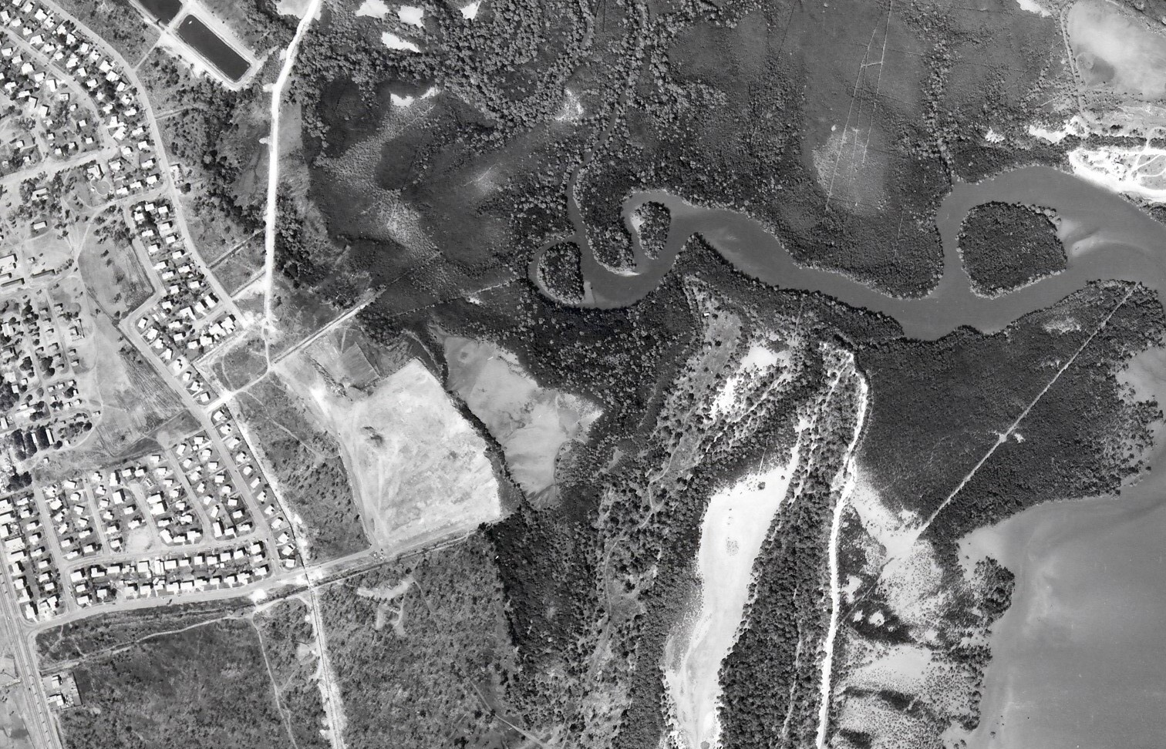
Illustration 1 (above): The Ludmilla dump site in the 1974 before Cyclone Tracy.
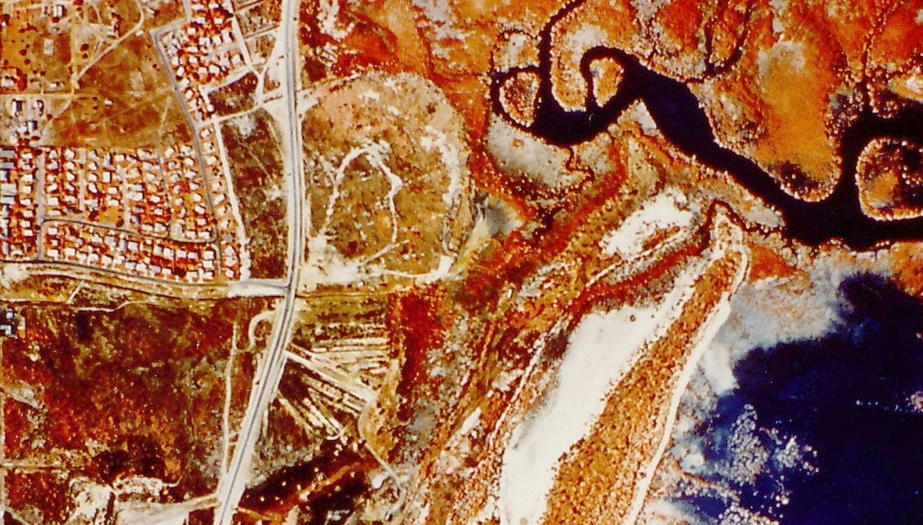
Illustration 2 (above): The Ludmilla Dump site in 1984 after the construction of Dick Ward Drive in the early 1980s and before Minmarama Village in 1986-9. The unused trenches are clearly visible.
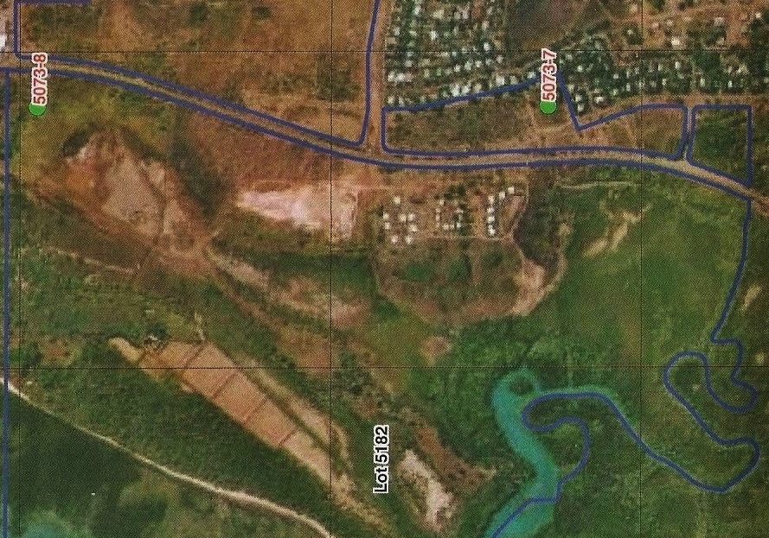

Illustration 3: Photo showing Minmarama Village on dump site and dump extension lower right (AAPA 2009).
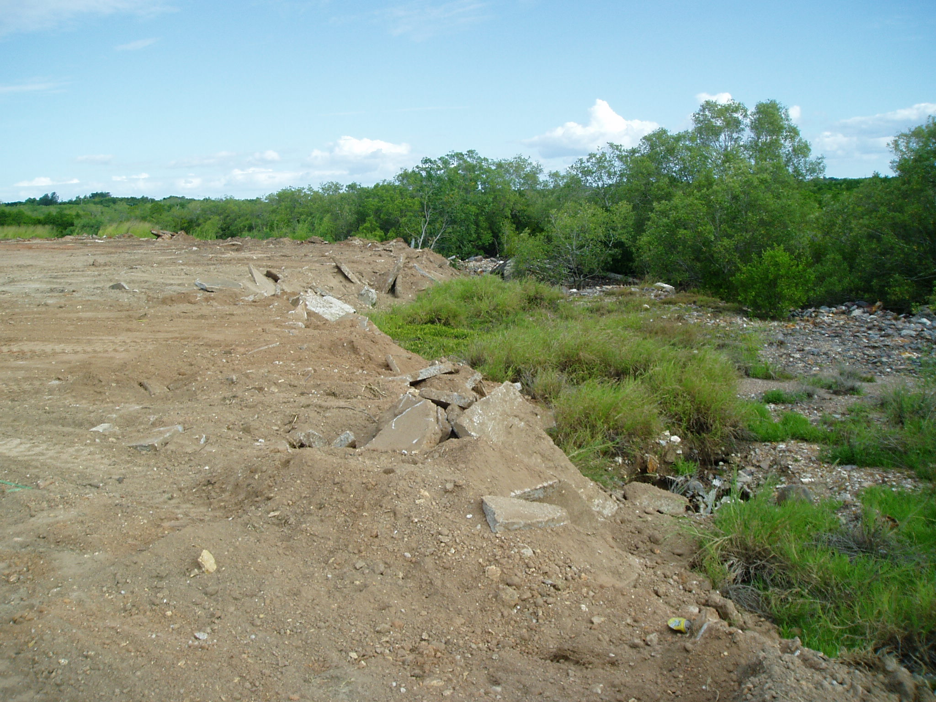

Illustration 4: What lies beneath? Extensions to Ludmilla dump behind Minmarama Village in 2009. (Also visible on previous aerial photo, Illustration 3). Photo sent to the EPA in 2018, taken by B Day, 2009.
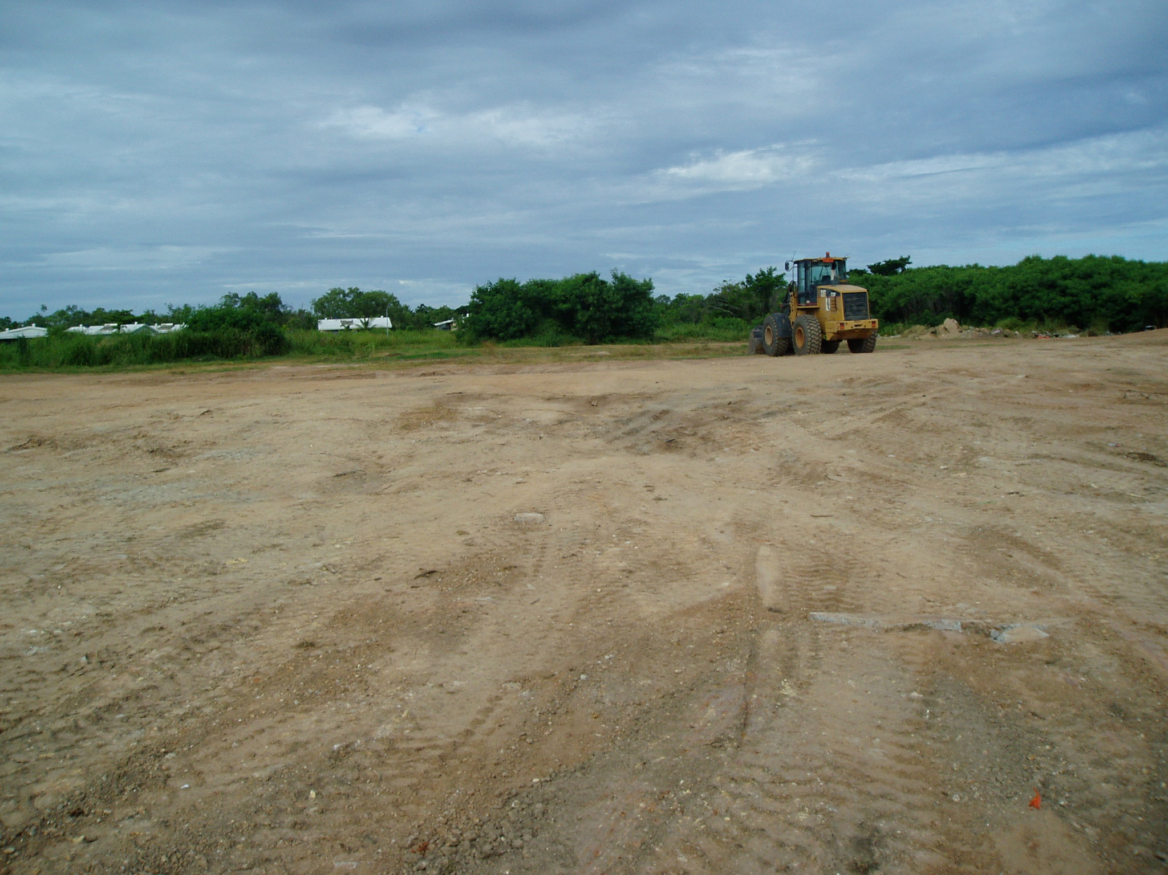

Illustration 5: What lies beneath? Levelling of unofficial extensions made to Ludmilla land fill site behind Minmarama Aboriginal Village (village rooftops visible, rear) in 2009. The area was used to dump unspecified construction waste in an arrangement between the leaseholders and a Darwin construction company. Previously Minmarama residents had used this area as their private dump. The residents complained when a locked gate was installed, restricting usage to a construction company which held the key, allegedly Venturin. In 2018, the NT EPA wrote, “Officers are unable to locate any permits or approvals granted by any government agency for reclamation behind Minmarama Village.” Photo by Bill Day, 2009.
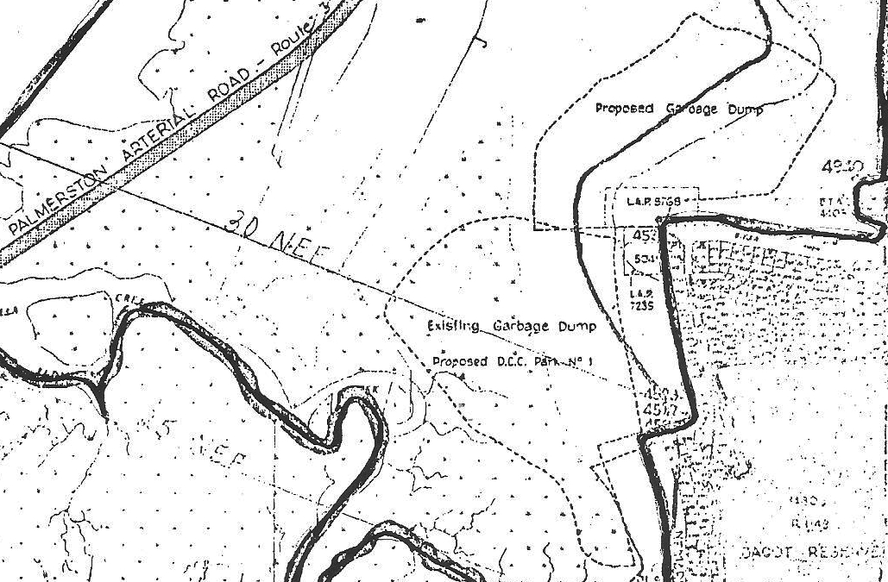

(Above) Map 1: A

Above: A cropped section of a map of proposed Kulaluk Lease boundaries which accompanied the media release by Minister for Aboriginal Affairs, Les Johnson on 16 July 1975 (see timeline). The map shows “Existing Garbage Dump – Proposed D.C.C. Park No. 1”. This was the Ludmilla Land Fill site as used 1972 -1979.
Also shown on the map is the area marked as “Proposed Garbage Dump”, in part of which approximately 14 trenches were excavated for the extensions before work stopped (see Illustration 2. Also see the aerial photograph on the cover of “Bunji: a story of the Gwalwa Daraniki Movement” by Bill Day, published by Aboriginal Studies Press in 1994). Only a few trenches were used before the re-opening of the dump area to dispose of wreckage from Cyclone Tracy. All the trenches in the “Proposed Garbage Dump” extension area were buried in 2006 under a mountain of contaminated construction waste, including concrete pours, dumped in a conservation zone by the Halikos Construction company, after a secret deal was negotiated with the leaseholders by a Darwin businessman, Ernie Chin.
The full map (Johnson 1975) also shows the route of the proposed “Palmerston Arterial Road” more commonly known as the “Palmerston Freeway”. Following public protest, plans for this road were shelved. Also shown: airport noise N.E.F. boundaries, tidal surge contours and the boundary of the Kulaluk lease midstream in Ludmilla Creek. Dotted areas are mangrove habitats. The suburb of Ludmilla North and the Bagot Aboriginal Community are lower right.
The Dick Ward Drive connector road (not shown) was constructed after an agreement was negotiated with the Larrakia Kulaluk claimants by NT Chief Minister Paul Everingham in 1978.

